Activity: • Create a Jenkins job that gets triggered every 1 minute. The source code is kept in https://github.com/AnjuMeleth/hello-world-java.git • Steps: • Create a Freestyle project and name it as HelloWorldCron • Provide the repository path in Source Code Management section • Enable Build periodically under Build Triggers.Provide the schedule as \*/1 \* \* \* \* • Select “Execute shell” under “Build” section. • Enter the commands javac HelloWorld.java • Save the configuration

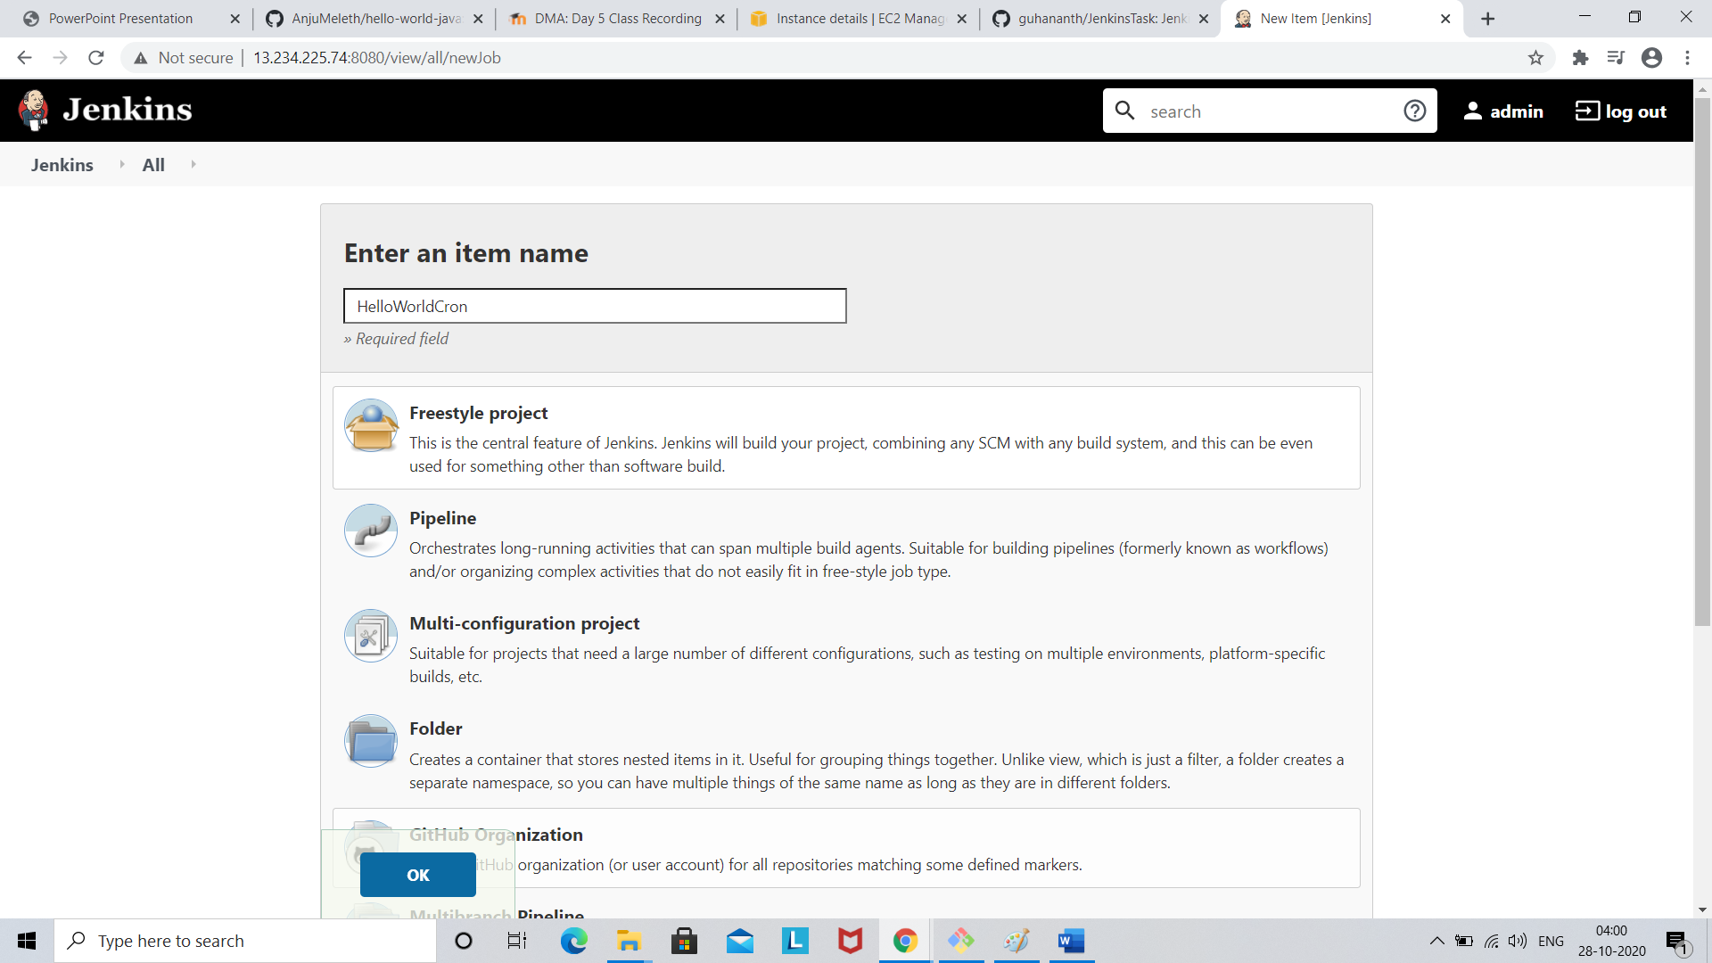

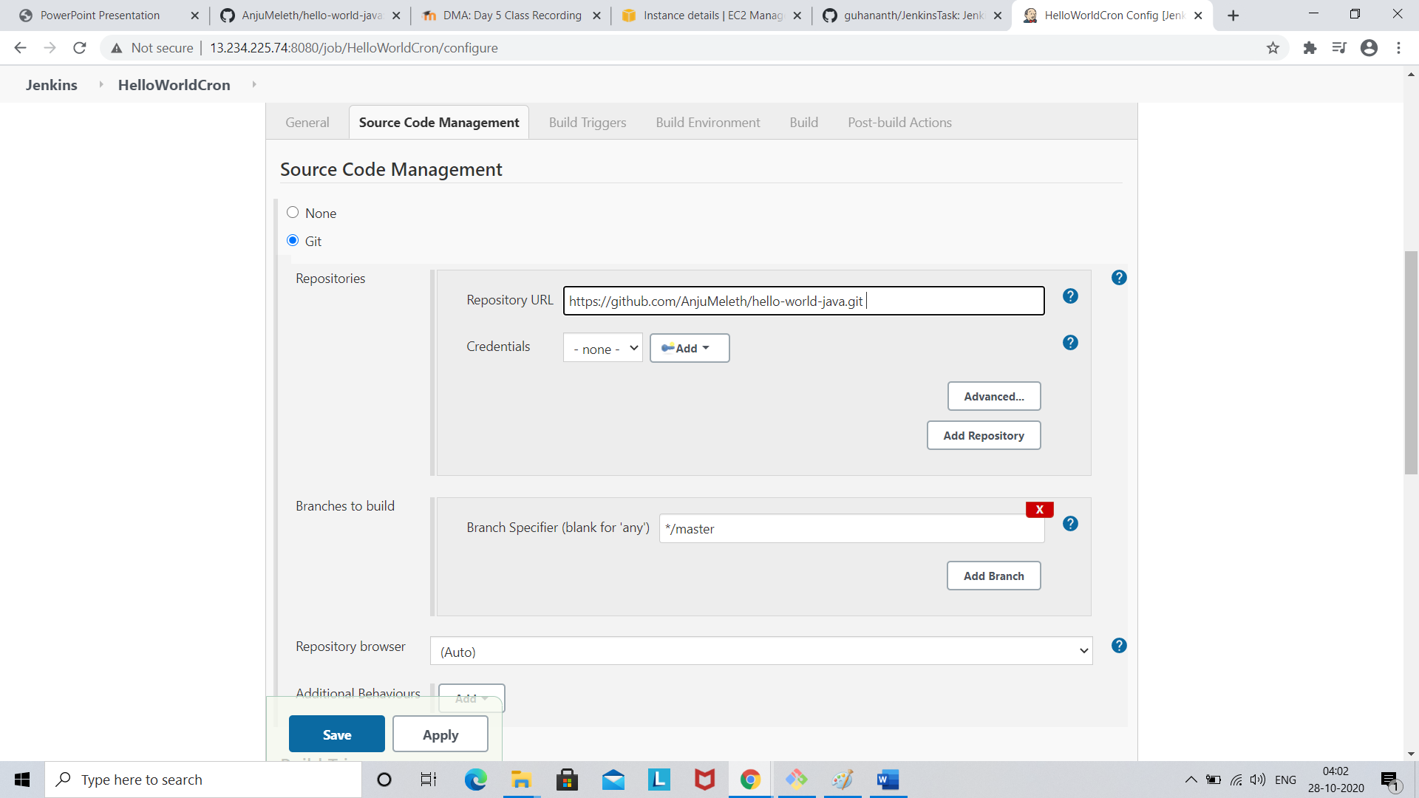

Go build trigger section

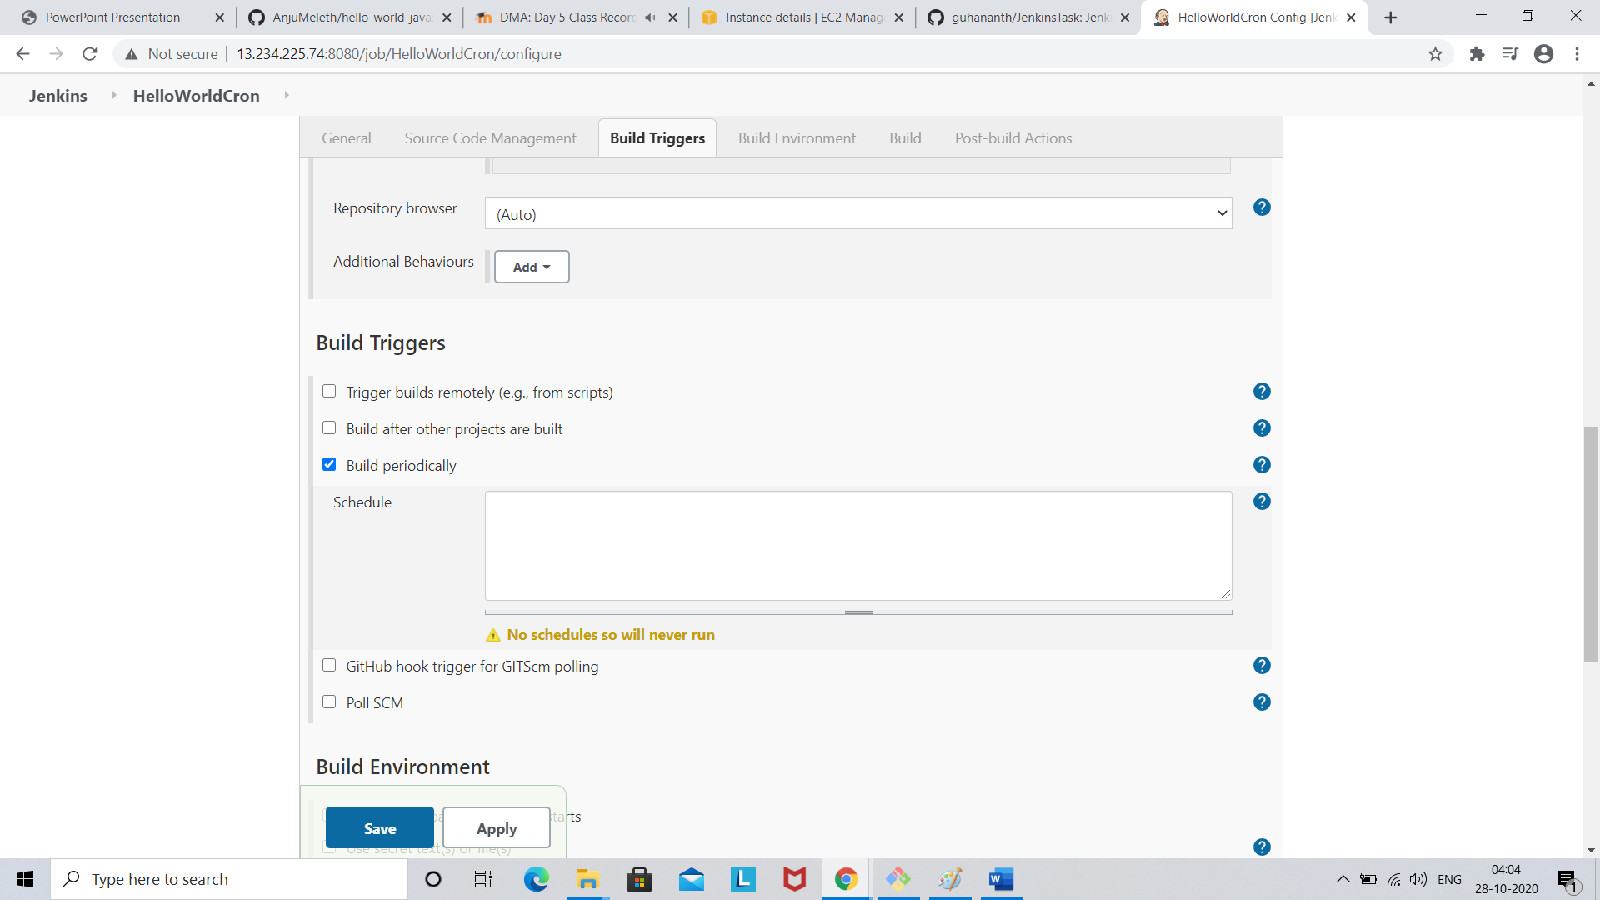

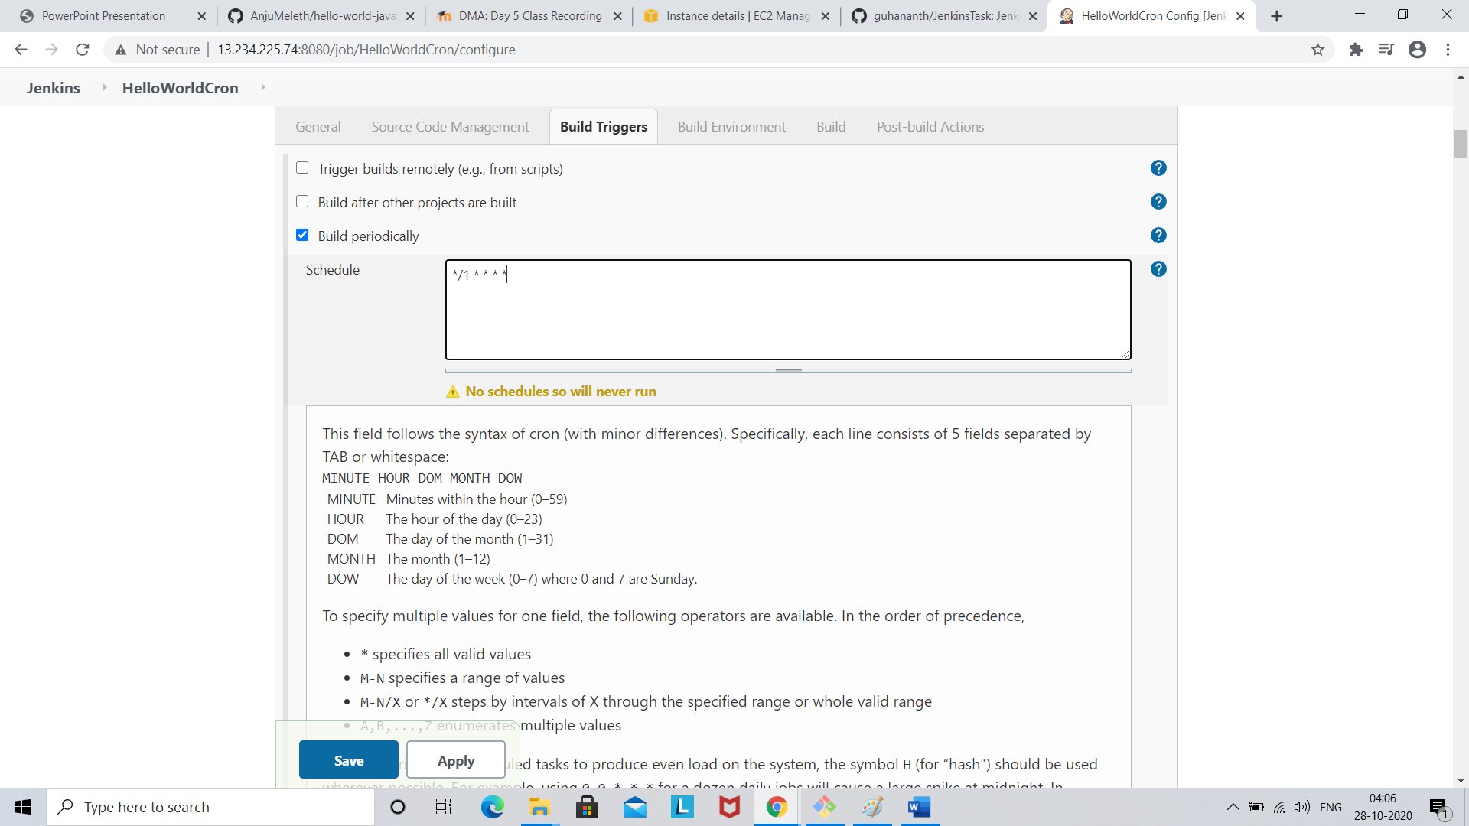

Click save

Click build

